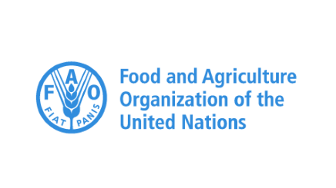

# FAOSTAT 3.0

**Sebastian Campbell**

*Submitted March 11, 2024*

A project submitted to UniLaSalle for the MSc Agricultural and Food Data Management with the Food and Agriculture Organization of the United Nations

**Jury**

*Laila Raddaf - Associate Professor in Statistics*

*Jérôme DANTAN - Enseignant-Chercheur, Informatique*

*Salima TAIBI*

*Christian Mongeau – Statistician at FAO*